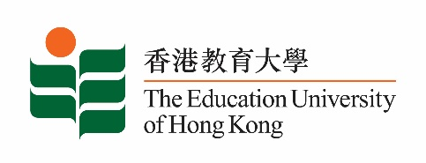
致： 傳媒機構採訪主任 (共 1頁) 6 November 2020
To : News Editors (total: 1 page)

香港教育大學2020年11月9至22日可供採訪之活動一覽
The Education University of Hong Kong (EdUHK) Events Calendar for 9 to 22 November 2020
本校誠邀 貴機構派員採訪下列活動。傳媒查詢，請聯絡教大傳訊處（電話：2948 6050）。
You are cordially invited to cover the events below. For media enquiries, please contact the Communications Office at 2948 6050.

因應2019冠狀病毒疫情，以下活動或有人數限制，傳媒請預先向主辦部門登記。
In light of the COVID-19 pandemic, there may be restrictions on the number of participants for the following event(s). Please contact the respective organiser(s) / department(s) for prior registration.

- 教大大埔校園 （新界大埔露屏路十號） / EdUHK Tai Po Campus (10 Lo Ping Road, Tai Po, New Territories)

日期  Date | 時間  Time | 活動  Event | 地點  Venue | 主辦部門及公眾查詢  Organiser &  Public Enquiry | 備註  Remarks
2020-11-21 | 2 - 4 pm | 新高中視覺藝術科應試策略講座  Seminars on DSE Visual Arts Exam Strategies 2020  講者 / Speaker:  劉仲嚴博士、譚祥安博士、Laurence James Wood教授、黃素蘭博士、順德聯誼總會梁銶琚中學陳蔚芝老師、教大學生  Dr Lau Chung-yim, Dr Thomas Tam Cheung-on, Professor Laurence James Wood, Dr Wong So-lan, Ms Chan Wai-chi from Shun Tak Fraternal Association Leung Kau Kui College, EdUHK students | 線上講座  ZOOM | 主辦部門 / Organiser:  文化與創意藝術學系  Department of Cultural and Creative Arts  查詢 / Enquiries:  羅小姐 Miss Law  電郵 / Email:  lawsy@eduhk.hk  電話 / Tel: 2948 8735 | 免費報名，歡迎各界人士參加。  Free Registration. All are welcome.  報名方法 / Registration： https://anonmachg2.eduhk.hk/machform/view.php?id=29700725  截止報名日期 / Deadline：2020-11-15

